AppDynamics

Pre Training Setup Guide

**2012**

Bill Hastings

AppDynamics

6/2/2012

Welcome to the AppDynamics Technical Training Setup guide. This guide has the instructions for you to setup an on premise solution for training purposes.

**What you need to do before the first session.**

First, use the information to login to our **support system** and download the install bundles for controller and agent appropriate to your PC or laptop (Windows or Linux, 32 or 64 bit).

To login to our Support System, please access:

<http://www.appdynamics.com/support.php>

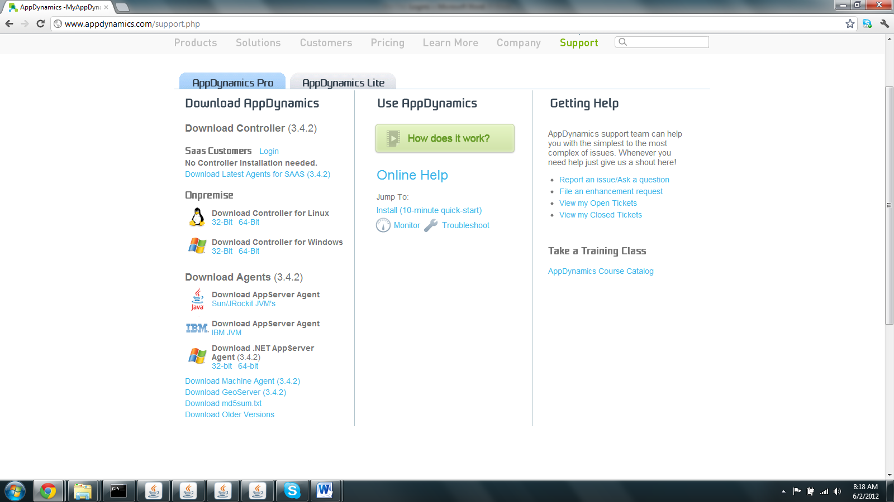

We will perform a series of lab exercises and it is expected that you have your own 'sandbox' environment. It is NOT required that you have the components installed already as this is one of the first practical exercises.

Please note that the training will be based on the 3.4.2 version of our product, the latest product capabilities such as EUM, Backend Views and Regression Analysis will be covered in the class presentations.

Please follow the instructions very carefully and have the desired setup components downloaded before **the first session** of the training.

Below you will find download instructions and references to help resources.   
  
To begin with, you will need to download the components detailed below from our Support System. Please use the download link to download the 3.4.2 version of both controller and agent.

To login to our Support System, please access:

Use these credentials to log in:

You can use your own login to download or he instructor will supply one at onsite classes

Please download the following components from the Download Center:

Note: There is no need to install the components this will be one of the Lab exercises we carry out in the first Unit:  
  
**Download the AppDynamics Controller:** The Controller collects and stores performance information in a central repository and performs aggregation and analysis on the collected data. The web-based user interface connects to the Controller to fetch performance data and to perform any configuration operations. Download the installer for the Controller for Linux (32 or 64 bit) or Windows with the file name controller_linux_version_32bit.sh or controller_linux_version_64bit.sh or controller_windows_version_32bit.exe. The installer file size is about 250MB. We recommend starting the download in advance of starting the evaluation.   
  
**Download the Java Application Server Agent:(Only required if you are using linux agents)** The Java Application Server Agent is specialized Java code that runs in the JVM process of a managed Application Server. It identifies Business Transactions and reports statistics and diagnostic data to the AppDynamics Controller every minute. Download the AppServerAgent.zip file for the AppServer Agent.   
  
**Download the .Net Application Server Agent:** (Only if you are running a .NET server ) The .Net Application Server Agent is specialized .Net code that runs in the IIS process of a managed Application Server. It identifies Business Transactions and reports statistics and diagnostic data to the AppDynamics Controller every minute. Download the dotNetAgentSetup.msi file for the .Net AppServer Agent.  Only if you are running a .NET server  
  
**Download the Machine Agent :** The Machine Agent is a self-contained collector of hardware performance data. It also can be configured to collect any dataset from your environment for correlation within the controller. It reports statistics and diagnostic data to the AppDynamics Controller every minute. Download the MachineAgent.zip file if you would like to use this during your trial.

**What you need to do on the first session of the class**

When you attend the class on Goto Meeting(not for onsites) you will be able to download all the necessary class files following joining the class. On the first session you will need to download

1. The **license.lic** file is needed for the software to run and is attached to this email. Save this file, you will need it to begin your trial. Copy the license.lic to the appdynamics-controller directory before you instantiate the controller.
2. The **testapp.zip** file this is the test server for the class environment
3. The **Studentguideappdynamics3.4.2.zip**
4. The **BDR-v4 .doc** file which is the Lab guide

# Course Agenda: For your information

# Delivery Units

1. Unit 1: Technology Focus
   1. Fundamentals
   2. Understanding requests, metrics and transactions
   3. Product Walk Through- Acme Online Store
   4. Installation
2. Unit 2: Monitoring real time applications
   1. Real Time Monitoring
   2. Distributed Transaction Tracing
   3. Infrastructure, Back End Performance & End User Monitoring
   4. Alerting & Remediation
3. Unit 3: Troubleshooting Performance Issues
   1. Triaging , Trouble shooting &Custom dashboards
   2. Diagnosing
   3. Memory Issues
4. Unit 4: Analysis, Automation and Administration
   1. Analysis
   2. Automation
   3. Controller Administration